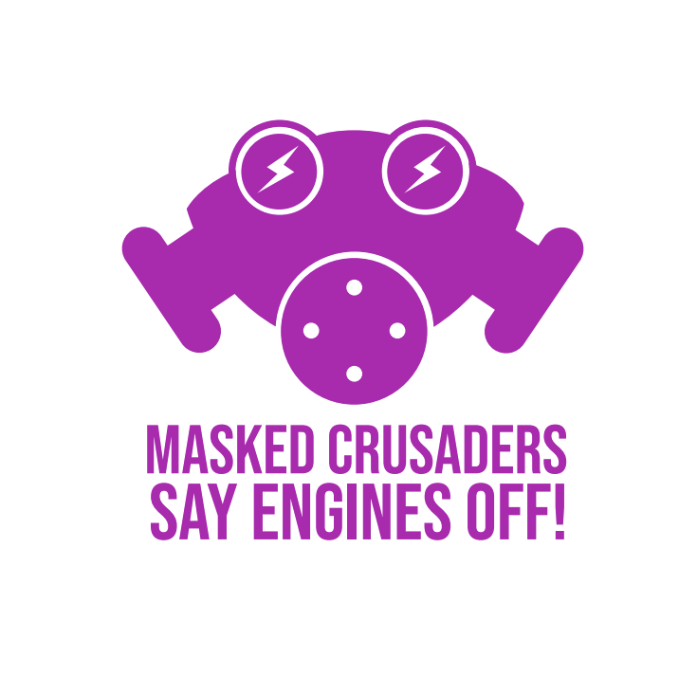
Dear Headteacher,

Thank you so much for your interest in this campaign, we would love your school to participate.

Air Pollution in London has been an increasingly serious issue, in fact A child born in London in 2010 will lose two years of life expectancy because of air pollution. We know that engine idling can needlessly add to the poor air quality around schools; as parents pick up and drop off children often leaving their engines running as they wait.

This campaign is designed to engage children to help stop parents, delivery drivers, and any others around schools leaving their engines running. We have created a pack of assets that you can use in and around your school. The campaign is designed in two parts. The first part is a series of simple, impactful posters, flyers, and social media communications that are designed to make people aware of the issue. The second part is an education and activation piece that can engage and educate the children. Culminating in a ‘Masked March’ on Friday 8th Nov.

We hope that you and your school will join us in the campaign.

Your Masked Crusaders Campaign Pack includes:

Part 1: Awareness Assets
1x large banner
3 x posters - various sizes, including canvas banner artwork
3 x double sided flyer
6 x animated social assets

Part 2: Education & Activation Assets
1x example newsletter copy & image
1 x mask making instruction sheet for kids
1 x assembly ppt deck

Don’t forget to photograph your children’s amazing mask creations & march and share on social media with the hashtag #enginesoff

Good luck Masked Crusaders!

Source: london.gov.uk, dudley.gov.uk *estimated if exposed to same level of pollution over their lifetime

